CHICAGO’S SLOW PULP SIGNS TO ANTI-
LISTEN TO CRUNCHY NEW TRACK “CRAMPS”
JUST ANNOUNCED: WEST COAST DATES WITH THE PIXIES THIS MAY
EUROPEAN TOUR WITH DEATH CAB FOR CUTIE BEGIN NEXT WEEK
Photo Credit: Tim Nagle
“Slow Pulp’s future is awash with possibilities, and that future is now.” - Paste
Chicago based four-piece Slow Pulp have signed to ANTI- Records and are announcing the signing today with the release of “Cramps,” a coolly crackling new track that sounds like it is pulling lead singer Emily Massey’s vocals through a distorted tape deck backed by the band’s well-honed blend of post-punk shoegaze. Listen to it below.
Listen to “Cramps”: https://youtu.be/u6Rzuldjyy8
“The song came out of a jam at practice right after I had proclaimed that my period cramps were particularly bad that day,” Massey explained. “It is about searching for things you wish you had in other people and creating this character in your head that has all the physical and emotional attributes you feel that you are lacking.”
Slow Pulp released their debut album ‘Moveys’ in late 2020, “a record that is packed with a thousand deft little flourishes of texture which together add up to a deeply entrancing whole,” said NME. It was not crafted quickly; Massey moved home to Wisconsin during the album’s writing process after a trifecta of issues arose: the COVID pandemic, a Lyme disease diagnosis and a car accident her parents were in that required her help in getting them back on their feet. Slowly but surely her health improved, and the band was able to collaborate in a new way and click into place.
"Slow Pulp have taken their adversities and turned them into something productive,” said The Line of Best Fit. “Through ripping up old ideas, processing their challenges and starting again, the band have been able to develop into a better band and even strengthen their lifelong friendship in the process.”
Next week Slow Pulp will embark on a month-long European tour with Death Cab for Cutie, followed by select May West coast dates opening for the Pixies. All upcoming dates are listed below.

TOUR DATES
3/5 - Copenhagen, Denmark @ Den Gra Hal ^
3/6 - Stockholm, Sweden @ Filadelfia ^
3/7 - Oslo, Norway @ Sentrum Scene ^
3/9 - Berlin, Germany @ Columbiahalle ^
3/10 - Tilberg, Netherlands @ 013 Poppodium ^
3/11 - Amsterdam, Netherlands @ Paradiso ^
3/12 - Cologne, Germany @ E-Werk ^
3/14 - Antwerp, Belgium @ De Roma ^
3/15 - Luxembourg, Luxembourg @ Atelier ^
3/16 - Paris, France @ Salle Pleyel ^
3/18 - Nottingham, England @ Rock City ^
3/19 - Dublin, Ireland @ Bord Gais Theatre ^
3/21 - Birmingham, England @ O2 Institute ^
3/22 - Edinburgh, Scotland @ Usher Hall ^
3/23 - Glasgow, Scotland @ Barrowland Ballroom ^
3/25 - Manchester, England @ Apollo ^
3/27 - Brighton, England @ Dome ^
3/28 - London, England @ Roundhouse ^
3/29 - London, England @ Royal Albert Hall ^
5/4 - Oakland, CA @ Fox Theater %
5/6 - Monterey, CA @ Golden State Theater %
5/8 - Phoenix, AZ @ Van Buren %
5/9 - Santa Fe, NM @ Lensic PAC %
5/12 - Las Vegas, NV @ Encore Theatre %
5/13 - Las Vegas, NV @ Encore Theatre %
^ - with Death Cab For Cutie
% - with the Pixies

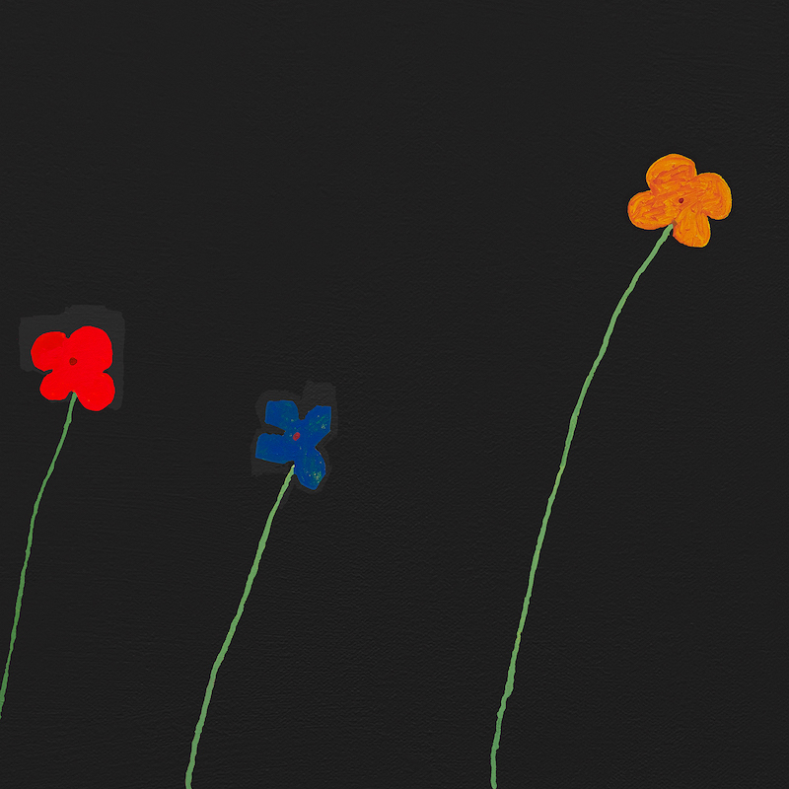
https://www.slowpulp.com/
Instagram | Facebook | Twitter
For More Info on Slow Pulp, Contact:
Kelly Kettering | ANTI- Records Publicity | kelly@epitaph.com

