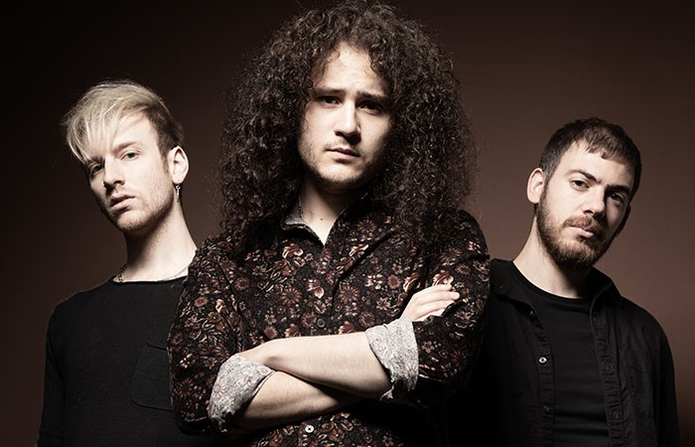
King Falcon – ‘Cadillac’ Bio
Michael Rubin - Lead Guitar and Vocals
James Terranova – Bass
Tom Diognardi - Drums

King Falcon’s Michael Rubin and James Terranova began their journey in music as hatchling birds—12 and 15 years old, respectively—playing in a band called The Inoculated Canaries. Weaned on classic rock and pop from studying at School of Rock, the teens fledged around New York City for years. But today, the Queens, New York natives spread their wings and soar as seasoned musicians with an exhilarating self-titled debut on Mascot Records.

“We were little birds when we started out,” King Falcon’s primary singer-songwriter and guitarist Michael Rubin says with a good-natured laugh. “We’ve been doing this for a lot of our lives, but we’re not canaries anymore—we’re full grown. The songs on this album speak to being little weird outcasts finding your way.”

King Falcon’s ultra-catchy songwriting sensibility melds classic rock swagger with indie-rock adventurousness, recalling artists such as the Black Keys, Cage The Elephant, Tame Impala, The Killers, Royal Blood, and Beck. The album brims with bluesy guitar riffage, sticky-sweet pop-punk choruses, soulfully melodic lead vocals, and vibrant indie-rock atmospherics. King Falcon is produced by Marshall Altman (Matt Nathanson, Marc Broussard, Kate Voegele, Frankie Ballard); mixed by 12-time Grammy-nominated mixing engineer and producer Mark Needham (The Killers, Imagine Dragons, Fleetwood Mac); and represents a powerful story of friendship, self-growth, and the bravery to go after a rock n’ roll fantasy.

Michael is the creative driving force behind King Falcon, but drummer and sometimes recording engineer James Terranova is essential to the band’s spirit. His fastidious, plan-ahead persona is the perfect counterpoint to Michael’s freewheeling personality, and the pair have an old-married-couple kind of connection. “I would take a bullet for him, but I may also be that person to shoot him,” Michael jokes. Up until now, King Falcon has been a guitar and drums duo, but the twosome is welcoming drummer Tom Diognardi and moving James to bass.

Michael’s fascination with music began through Guitar Hero, but his father kept poking fun at his steely determination to master the game. “My dad would say, ‘You spend so much time in front of the TV with that thing, why not learn real guitar?!?’,” Michael recalls, chuckling. Michael eventually took his pop’s words to heart, got a guitar, and enrolled in School of Rock. He studied there from the ages of 10-16, and immersed himself in the institution’s “real band” performance philosophy.

Hungry for more music opportunities outside the program, Michael put together a cover band with some of his buddies, but romances with the female vocalists caused Fleetwood Mac-style drama. This forced Michael, then a dedicated guitarist, into becoming a lead singer. That band morphed into The Inoculated Canaries. TIC toured consistently throughout the northeast, and showcased at the SXSW conference in Austin and the 2020 NAMM convention in Anaheim, CA.

Michael and James decided to go in a new direction musically, so TIC disbanded and King Falcon was born. In 2020, the duo released the funky and infectiously catchy single, “Shake! Shake! Shake!” However, the pandemic cleared King Falcon’s calendar before it even got a chance to play a show. The guys made the most of the situation by sending its single, “When The Party Is Over,” out to labels. “That song represented me trying to convince my parents, and myself, that I could get somewhere playing guitar,” Michael says. The song turned out to be aces for the band. King Falcon emailed the song to Mascot, and the next day was awarded with a recording contract.

“When The Party Is Over” is an irresistible, moody mid-tempo rocker teeming with ear worm melodies. The song explores lonely New York late-night living with gritty candor, and it comes alive via a darkly alluring video. “We got chased through the park by a crazed man with a knife while making the song’s video,” Michael remembers.

New single “Cadillac” snapshots an actual Ferris Bueller-like joyride with a buddy’s red, rare bird 1957 Eldorado Cadillac. “Long story short, I got to drive this beauty with no brakes, no plates, and a flat tire—everybody, including the cops, waved as I cruised this spaceship around the neighborhood,” Michael says. The song’s engrossing narrative comes to life via a vibrant animation enhanced video.

Now, King Falcon will resume its pre-pandemic plans of playing its first live shows and touring. “It took two and a half years to get here,” Michael says, pausing thoughtfully. “If you asked me when I first got my guitar if we would get a label and be where we are today, I would have said, ‘oh yeah, no problem,’ but I’ve learned the reality of it all isn’t that simple. It is amazing to be where we are today, but it was definitely a challenging journey.”

**
Connect and Share with King Falcon
Official website / TikTok / Instagram / Facebook / Twitter / Youtube

